
A14
Sreenidhi Institute of Science and Technology
(An Autonomous Institution)
Code No: 4H111
B. TECH. I – Year I – Semester Examinations, December 2015 (Supplementary)
ENGINEERING MATHEMATICS – I (Common to All Except-BT)

Time: 3 Hours Max. Marks: 70

Note: No additional answer sheets will be provided.

Part - A
Max.Marks:20

Answer all QUESTIONS. EACH QUESTION CARRIES 2 MARKS.
- State Cauchy’s mean value theorem.
- In polar co-ordinates, x = r cos, y = r sin show that 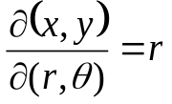.
- Find the substitution required to convert the equation xy(1+xy²) 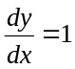 in to linear differential equation in z.
- Define orthogonal trajectories.
- Define an ordinary linear equation of order n with constant coefficients.
- Find the particular integral of (D³ – 6D² + 11D – 6) y = e^{-2x} + e^{-3x} .
- Define a Saddle point.
- Evaluate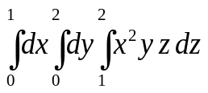.
- Explain physical interpretation of curl.
- Explain when velocity “v” is conservative.
Part – B
Max.Marks:50
ANSWER ANY FIVE QUESTIONS. EACH QUESTION CARRIES 10 MARKS.

- (a) Using Mean value theorem. Determine C lying between a and b, if
f(x) = x(x-1) (x-2), if a = 0, and b = ½ .

(b) Verify that 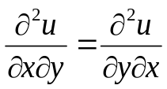 when u = log (y sin x + x sin y).

- (a) Solve 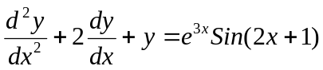
(b) Solve 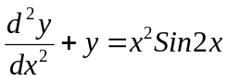

- (a) Solve the equation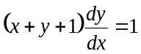.

(b) Find the orthogonal trajectories of the family of curves x^{2/3} + y^{2/3} = a^{2/3} where a is
the parameter.

- (a) Solve the equation (D² – 3D + 2) y = cos 3x.

(b) Solve (D² + D) y = x² + 2x + 4.

- (a) Find the volume bounded by the xy – plane, the cylinder x² + y² =1 and the plane
x + y + z =3.

(b) Evaluate 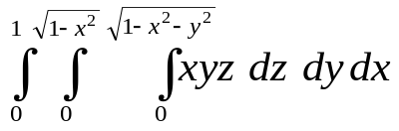

- (a) If u=x²-2y, v =x+y+z, w= x–2y+3z find 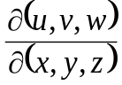 .

(b) Examine for minimum and maximum values of sinx + siny + sin (x+y).

- (a) Find the directional derivative of the function f = x² – y² + 2z² at the point
P = (1, 2, 3) in the direction of the line P Q where Q = (5, 0, 4).

(b) Find constants a,b and c if the vector
is irrotational.

- (a) Prove that force field given by 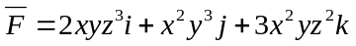is conservative.

(b) Using Green’s theorem 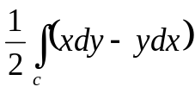 on a simple closed curve C and hence find the
area of ellipse x = a cos, y = b sin of 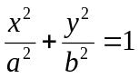
***

-- 00 -- 00 --

